Patrick Morley

Professor Holden-Gouveia

Linux Administration

CentOS Documentation

Next, I set up CentOS on my raspberry pi. It took some trial and error. I downloaded some wrong files a couple of times. I read from several different websites to figure out how to download the correct file and properly install it. I went to <http://isoredirect.centos.org/altarch/7/isos/armhfp/> and downloaded file <http://mirrors.ocf.berkeley.edu/centos-altarch/7.7.1908/isos/armhfp/CentOS-Userland-7-armv7hl-RaspberryPI-Minimal-4-1908-sda.raw.xz>. I then used 7-zip to extract the file. I put my micro SD card into the SanDisk adapter and put it in my computer.

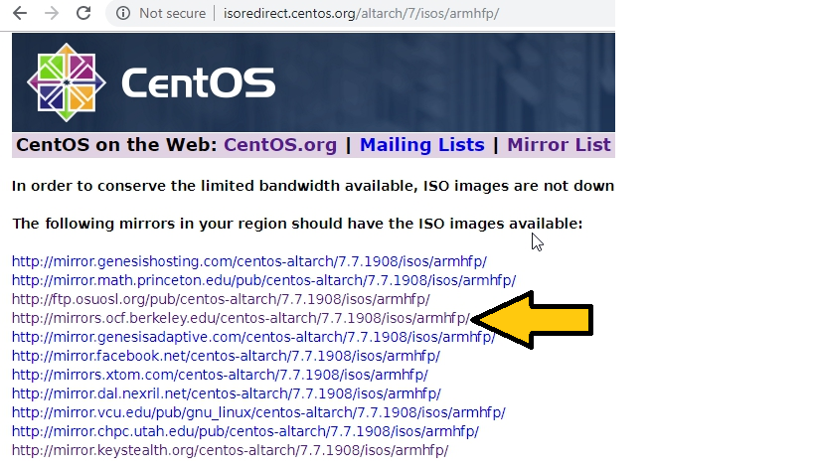

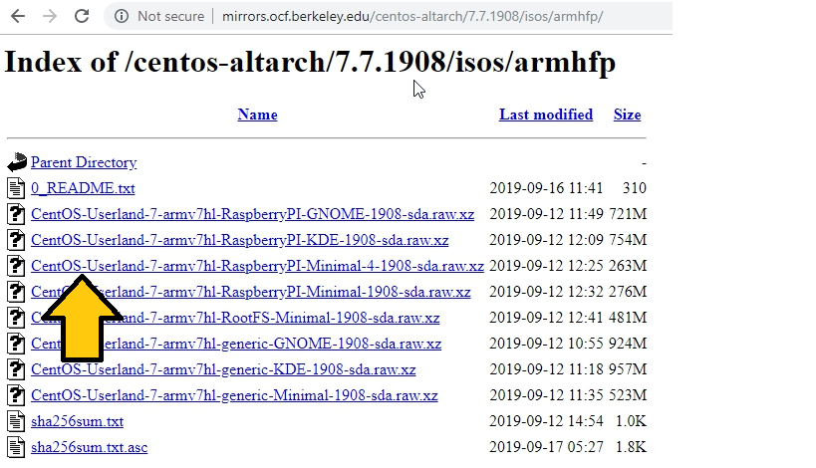

Then I opened Rufus (which is a universal USB installer). I selected the file I had extracted and left all other options at their defaults and started the program.

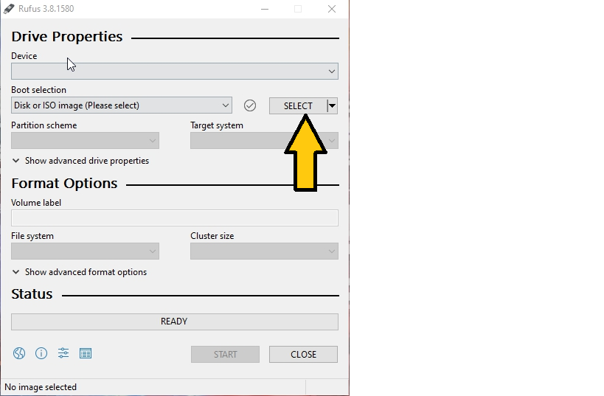

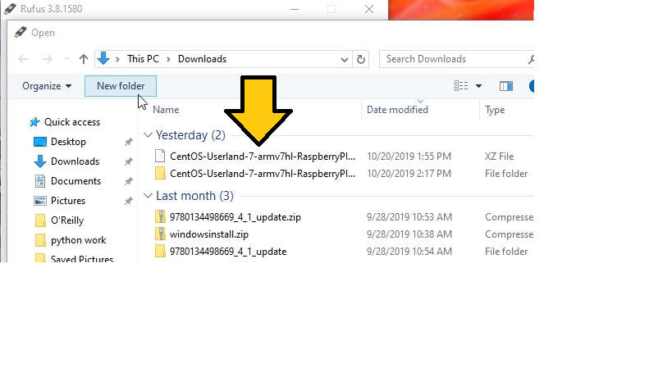

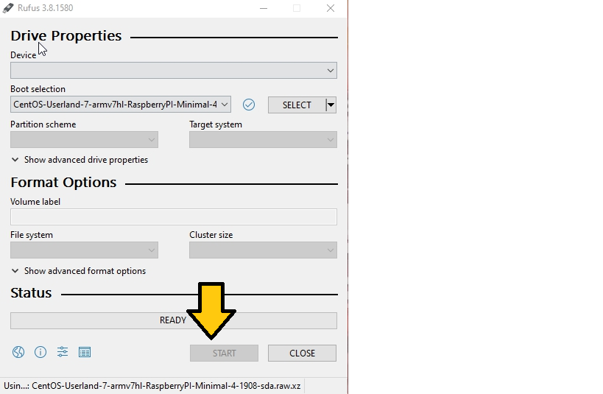

After the image was fully loaded onto the SD card, I inserted into my raspberry pi. I connected the HDMI cable to my tv and plugged in the power cable, then turned it on. After logging in with the startup user information, I created a new user account and password. I connected to wifi by entering these commands: chkconfig NetworkManager on, service NetworkManager start, and nmtui. This launched the network manager text user interface which I used to connect to my wifi. After this I was able to run yum update.

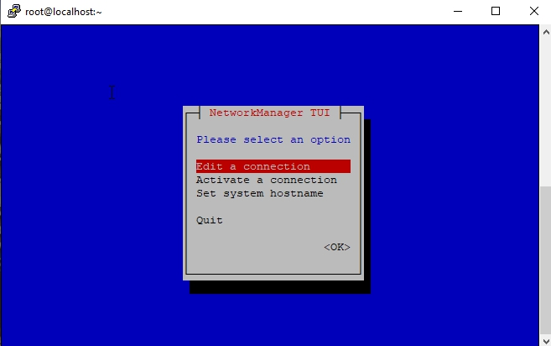

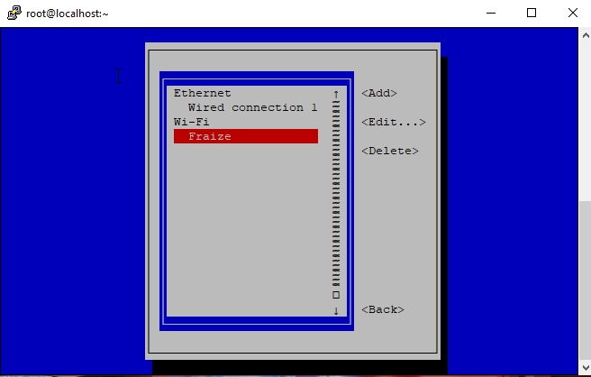

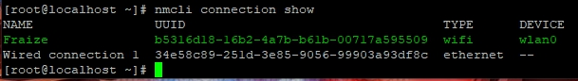

These are some of the sites I read to learn how to install CentOS to a raspberry pi:

<https://tecadmin.net/install-centos-raspberry-pi/>

<https://raspberrypi.stackexchange.com/questions/42257/installing-centos-7-on-a-raspberry-pi>

<https://medium.com/@petermcd/installing-centos-on-a-raspberry-pi-2112e9ee68fc>

<https://github.com/rharmonson/richtech/wiki/Using-CentOS-7.2.1511-Minimal-on-the-Raspberry-PI-3>

<https://unix.stackexchange.com/questions/370318/how-to-connect-to-wifi-in-centos-7clino-gui>

**CentOS: starts at the directory labeled root@localhost**

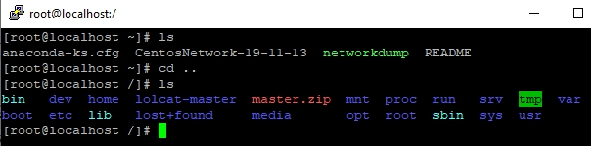

/bin:

/etc: SEE

/home:

/opt: PICTURE

/tmp:

/usr: ABOVE

/var:

/etc/passwd: SEE

/etc/shadow:

/etc/group: PICTURE

/etc/login.defs:

/etc/adduser.conf:

/etc/sudoers: BELOW

/etc/motd:

/etc/skel:

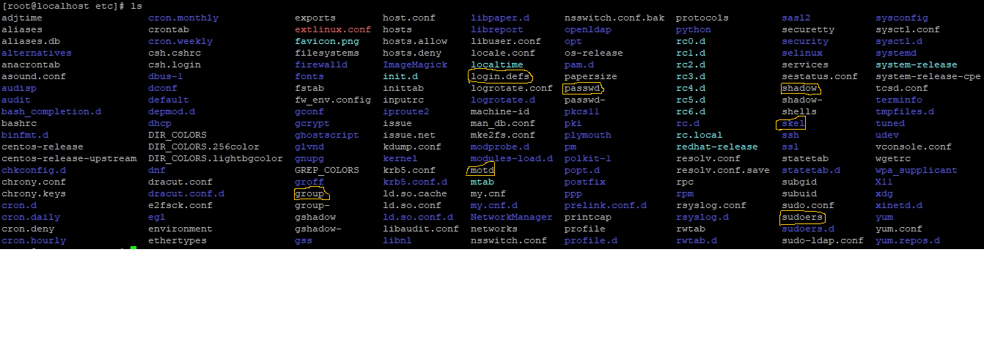

**Repositories:**

Yum repolist shows what repos are enabled. Yum repolist all shows all enabled and disabled repos. Dnf config-manager –add-repo <http://rpms.famillecollet.com/enterprise/remi-release-7.rpm>

**INSTALLS:**

Yum install tmux

While trying to install emacs I found out I had no more space left on my partition. So, I had to figure out how to expand my partitions because I was only using about 2GB of my 32GB SD card. I used yum install parted to install a program I could use to configure my partitions. I used command parted to enter the program and print to see how my partitions were set up. Next I entered resizepart, when asked Partition number? I entered 3, when asked End? [GB]? I entered 250000 (for 25GB). I then did a reboot. Fdisk /dev/mmcblk0 then command p showed the partition was larger, but the root file system still had its old size. Next, I used resize2fs /dev/mmcblk0p3 to extend the root file system. E2fsck -f /dev/mmcblk0p3 checked for errors, and df -h showed that I now had 21GB of space left.

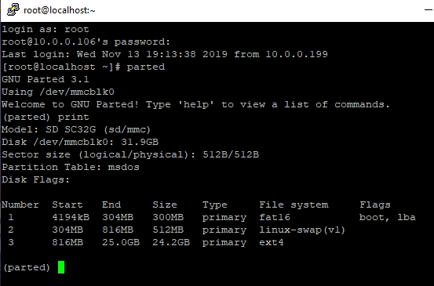

Yum install emacs

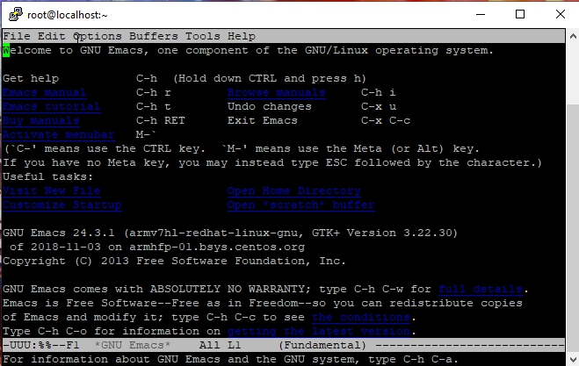

I cannot install Fail2Ban without installing the EPEL repository first and there is no EPEL for my version of CentOS. I also cannot install cowsay or fortune without the EPEL repository either.

I did manage to install lolcat with these steps. Yum install ruby, Yum install wget, Wget <https://github.com/busyloop/lolcat/archive/master.zip>, Yum install unzip, Unzip master.zip, cd lolcat-master/bin, gem install lolcat.

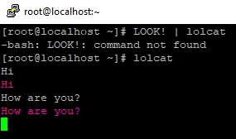

Update VI to vim:

Sudo rpm -Uvh <http://mirror.ghettoforge.org/distributions/gf/gf-release-latest.gf.el7.noarch.rpm>

Sudo rpm –import <http://mirror.ghettoforge.org/distributions/gf/RPM-GPG-KEY-gf.el7>

Sudo yum -y remove vim-common vim-enhanced vim-filesystem

Sudo rpm -e –nodeps vim-minimal

Sudo yum -y –enablerepo=gf-plus install vim-enhanced

SSH:

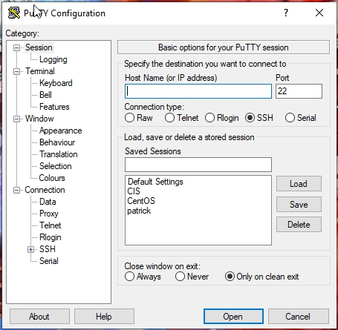

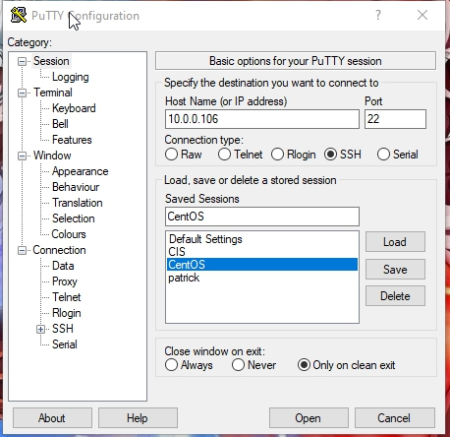

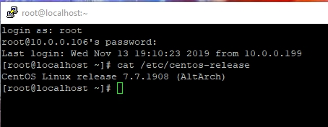

**Network:**

Ip address

Nmcli device show wlan0

Netstat -lntu

